3/10/2024

**SUBMITTED BY**

**MUBEENA D**

**MY HOME WIFI**

1. Identify the Internet Service Provider (ISP). Do they have an ASN?

Asianet Movies.

Yes, **Asianet** has an Autonomous System Number (ASN). The ASN for MTNL is **AS17813**.

1. What is the model of the WiFi router? Provide an image of the router.

Genexis Platinum

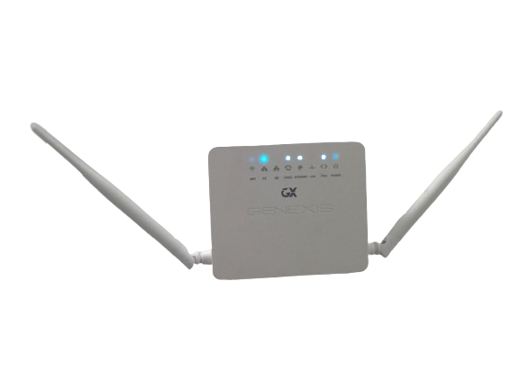

1. How is the router connected to the WAN?

ONT via optical fiber

1. Is the WIFI password still the default one provided by the ISP? If yes, list the password. If not, try to find out what the default password is and include it here.

Yes, password provide is **04702993314**

1. Default passwords are not secure. With consent from everyone using the WiFi network, change it to a secure password (Make sure to store it safely). Did you face any resistance from the users? If so, describe the situation.

After discussing the matter on security with the users of the WiFi network, I suggested changing the default password to a safer password. Most people did not feel anything but some of them said that they will have to update their devices to accommodate the change. But one member was so resistant that she feared that she would forget the new password. So I assured them that it was saved in their devices

1. What is the default IP range of the network? What is the IP of the default gateway? Is it the same as that of the router? Also, find the default DNS server.

* Default ip range : 192.168.1.2 – 192.168.1.254
* Default Gateway : 192.168.1.1, Yes it is same as that of the router
* Default DNS : 192.168.1.1

1. Can you access the router login page? (Include screenshots)

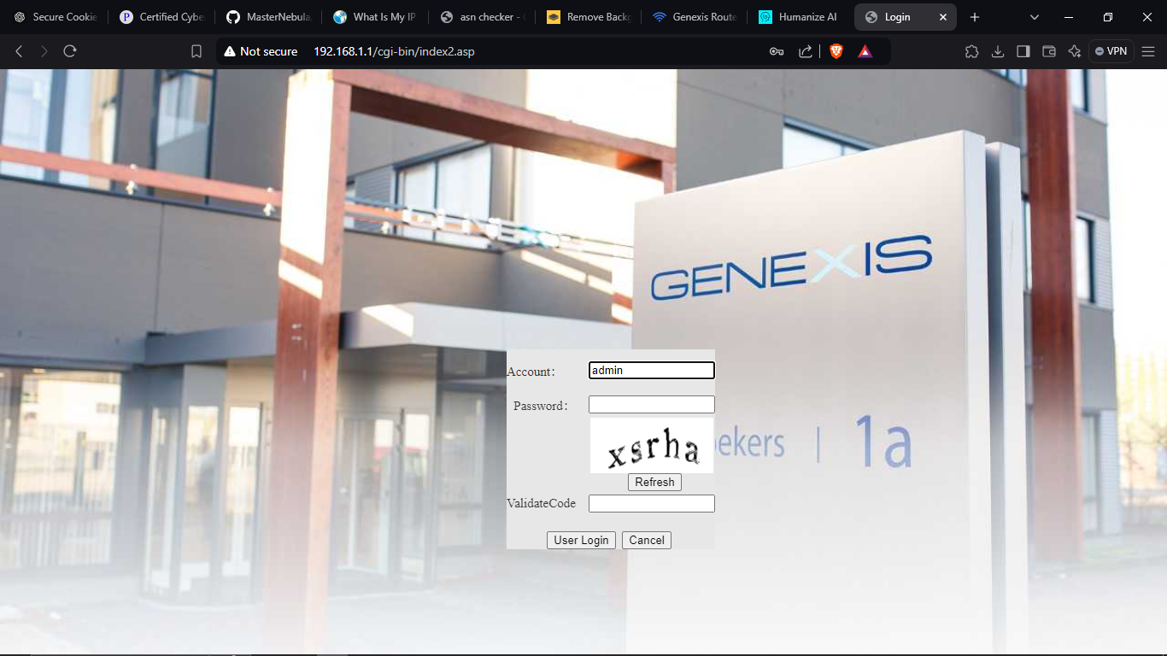

1. Do you know the credentials for the router login page?

Yes, it is provided on the back side of the router.

1. If the router login credentials are the default ones provided by the ISP, list them here and then change them to a secure password of your choice (Remember to store it safely).

Yes, the default credentials is **BC62D20C8118**

10. How many devices are connected to the network? How many can you identify? Do they respond to pings? Create a table and list all the information you found about the devices on the WiFi network.

Yes, I ping the devices through the command prompt. All of them are responding to it

